

Project Report

Enterprise Systems [INT 308]

ERP Implementation for IKEA

Done By:

Sara Al Najjar – 202110946

Joti Rani Biswas - 202011604

Misba Maksoud – 202111192

Rayan Hassan – 201920024

Iqra Mujtaba – 20211072

Ebtehal Ahmed – 202010020

Instructor:

Dr. Ammar Rashid

Table of Contents

Introduction 3

About IKEA 3

ERP 3

ERP Implementation at IKEA 4

Maintenance 4

Sales 5

Products 7

Inventory 7

Purchase 8

Accounting 9

Survey 9

Marketing 10

Social Media Marketing 10

E-mail Marketing 11

Discuss 12

Employees 12

Website 13

Calendar 14

Conclusion 14

References 15

# Introduction

## About IKEA

IKEA, a name inseparable from reasonable furnishings and home products, has changed the way people furnish their living spaces since its origin in 1943. Established by Ingvar Kamprad in Älmhult, Sweden, IKEA started as a private venture selling pens, wallets, tablecloths, watches, gems, and nylon stockings through mail orders. The addition of furniture to its catalogue in 1948 denoted the start of IKEA's emphasis on minimal expense, and stuffed furnishings, a progressive idea that empowered more straightforward delivery and helpful self-assembly by their customers. Today, IKEA is famous for its down-to-earth and up-to-date furniture as well as for its exceptional shopping experience. IKEA stores, frequently huge blue structures with yellow accents, are decisively intended to direct clients through a one-way, displaying completely furnished rooms and visualising living spaces. This format urges clients to envision the items in their own homes and gives a vivid shopping experience. IKEA's commitment to sustainability and design advancement keeps on being fundamental to its mission. The organization emphasizes the utilization of eco-friendly materials and processes, planning to limit its effect on the environment while making quality home furnishers available to whatever number of individuals as could reasonably be expected. With many stores across the globe, IKEA has not just turned into a forerunner in the retail furniture industry but additionally an important part of mainstream society, impacting home design and lifestyle around the world.

## ERP

An Enterprise Resource Planning (ERP) system is a type of software utilized by organizations to oversee and coordinate the main processes essential for maintaining their business. ERP systems act as a concentrated platform to smooth out and automate processes across different sectors, facilitating information flow and assisting organizations with settling on information-driven choices.

Key elements and functionalities of ERP frameworks include:

* Integration: ERP systems integrate all departments, creating a unified system which lessens the requirement for manually connecting each department to another, which can assist with efficiency and the rate at which work is completed.
* Automation: ERP systems can automate processes, which leads to diminishing errors and increasing proficiency in processes compared to manually being completed.
* Customer Relationship management: ERP systems frequently incorporate CRM parts to manage all parts of CRM, from sales to support, upgrading the client experience and further developing relationships with clients.

Overall, an ERP system creates a more coordinated organization that can increase functional proficiency, and support growth and development through promoting inter-departmental collaboration.

## ERP Implementation at IKEA

Implementing an ERP system (Odoo) for a worldwide and complex organization like IKEA could offer various vital advantages, assisting with smoothing out tasks and support development such as Supply Chain Optimization, Inventory Management, Customer Relationship Management, Human Resources Management, Real-Time Data and Analytics and so much more.

Here are the following modules used in our ERP (Odoo) implementation for Ikea:

* 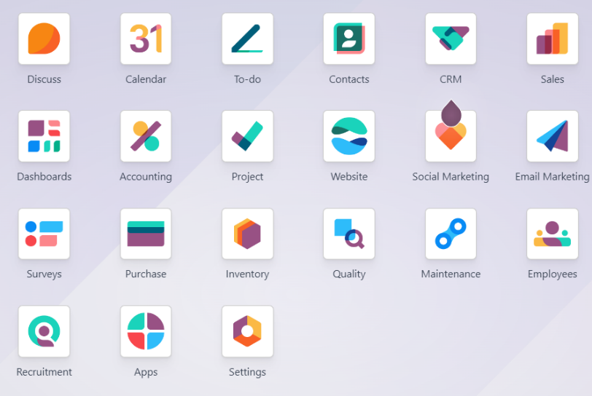Inventory
* Sales
* Surveys
* Invoicing
* Employees
* Sales
* Website
* Maintenance
* Products
* Purchase
* Accounting
* Marketing (E-mail / Social)
* Calendar

**Figure 1.1**

By implementing an ERP system, IKEA would have the option to deal with its complicated activities more effectively, upgrade its responsiveness to client needs, and keep up with its strategic advantage in the global market.

# Maintenance

The maintenance team at IKEA makes sure all machines and production equipment are working properly and efficiently. They use functions offered by this module to handle different types of maintenance tasks like preventive, corrective and predictive maintenance. With this tool, they can schedule maintenance tasks, keep track of request history, and assign maintenance jobs to technicians. It works with other modules of the system, like employees, inventory, and purchase modules.

We've set up three maintenance requests at different stages such as new request, in progress and repaired and scrap. Each request has stars showing the urgency and importance of the requests, and there's an employee in charge of each assigned request. We've also listed all the types of equipment and assigned operators and work centres to each machine.

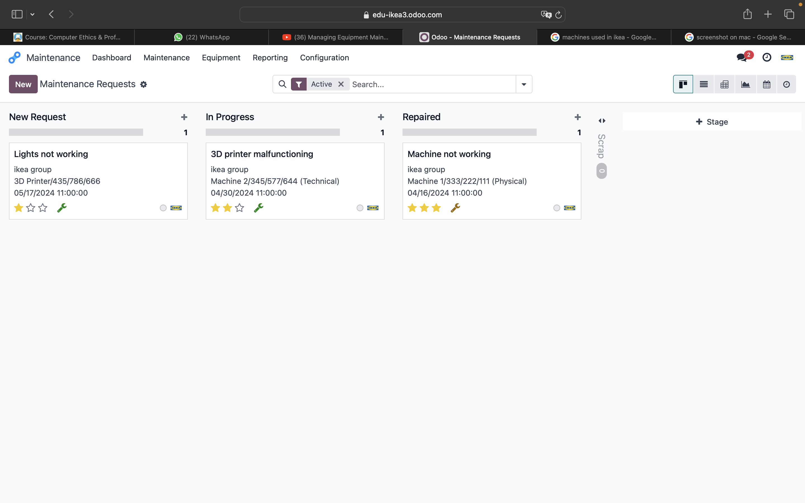

**Figure 2.1** kanban view of our maintenance requests.

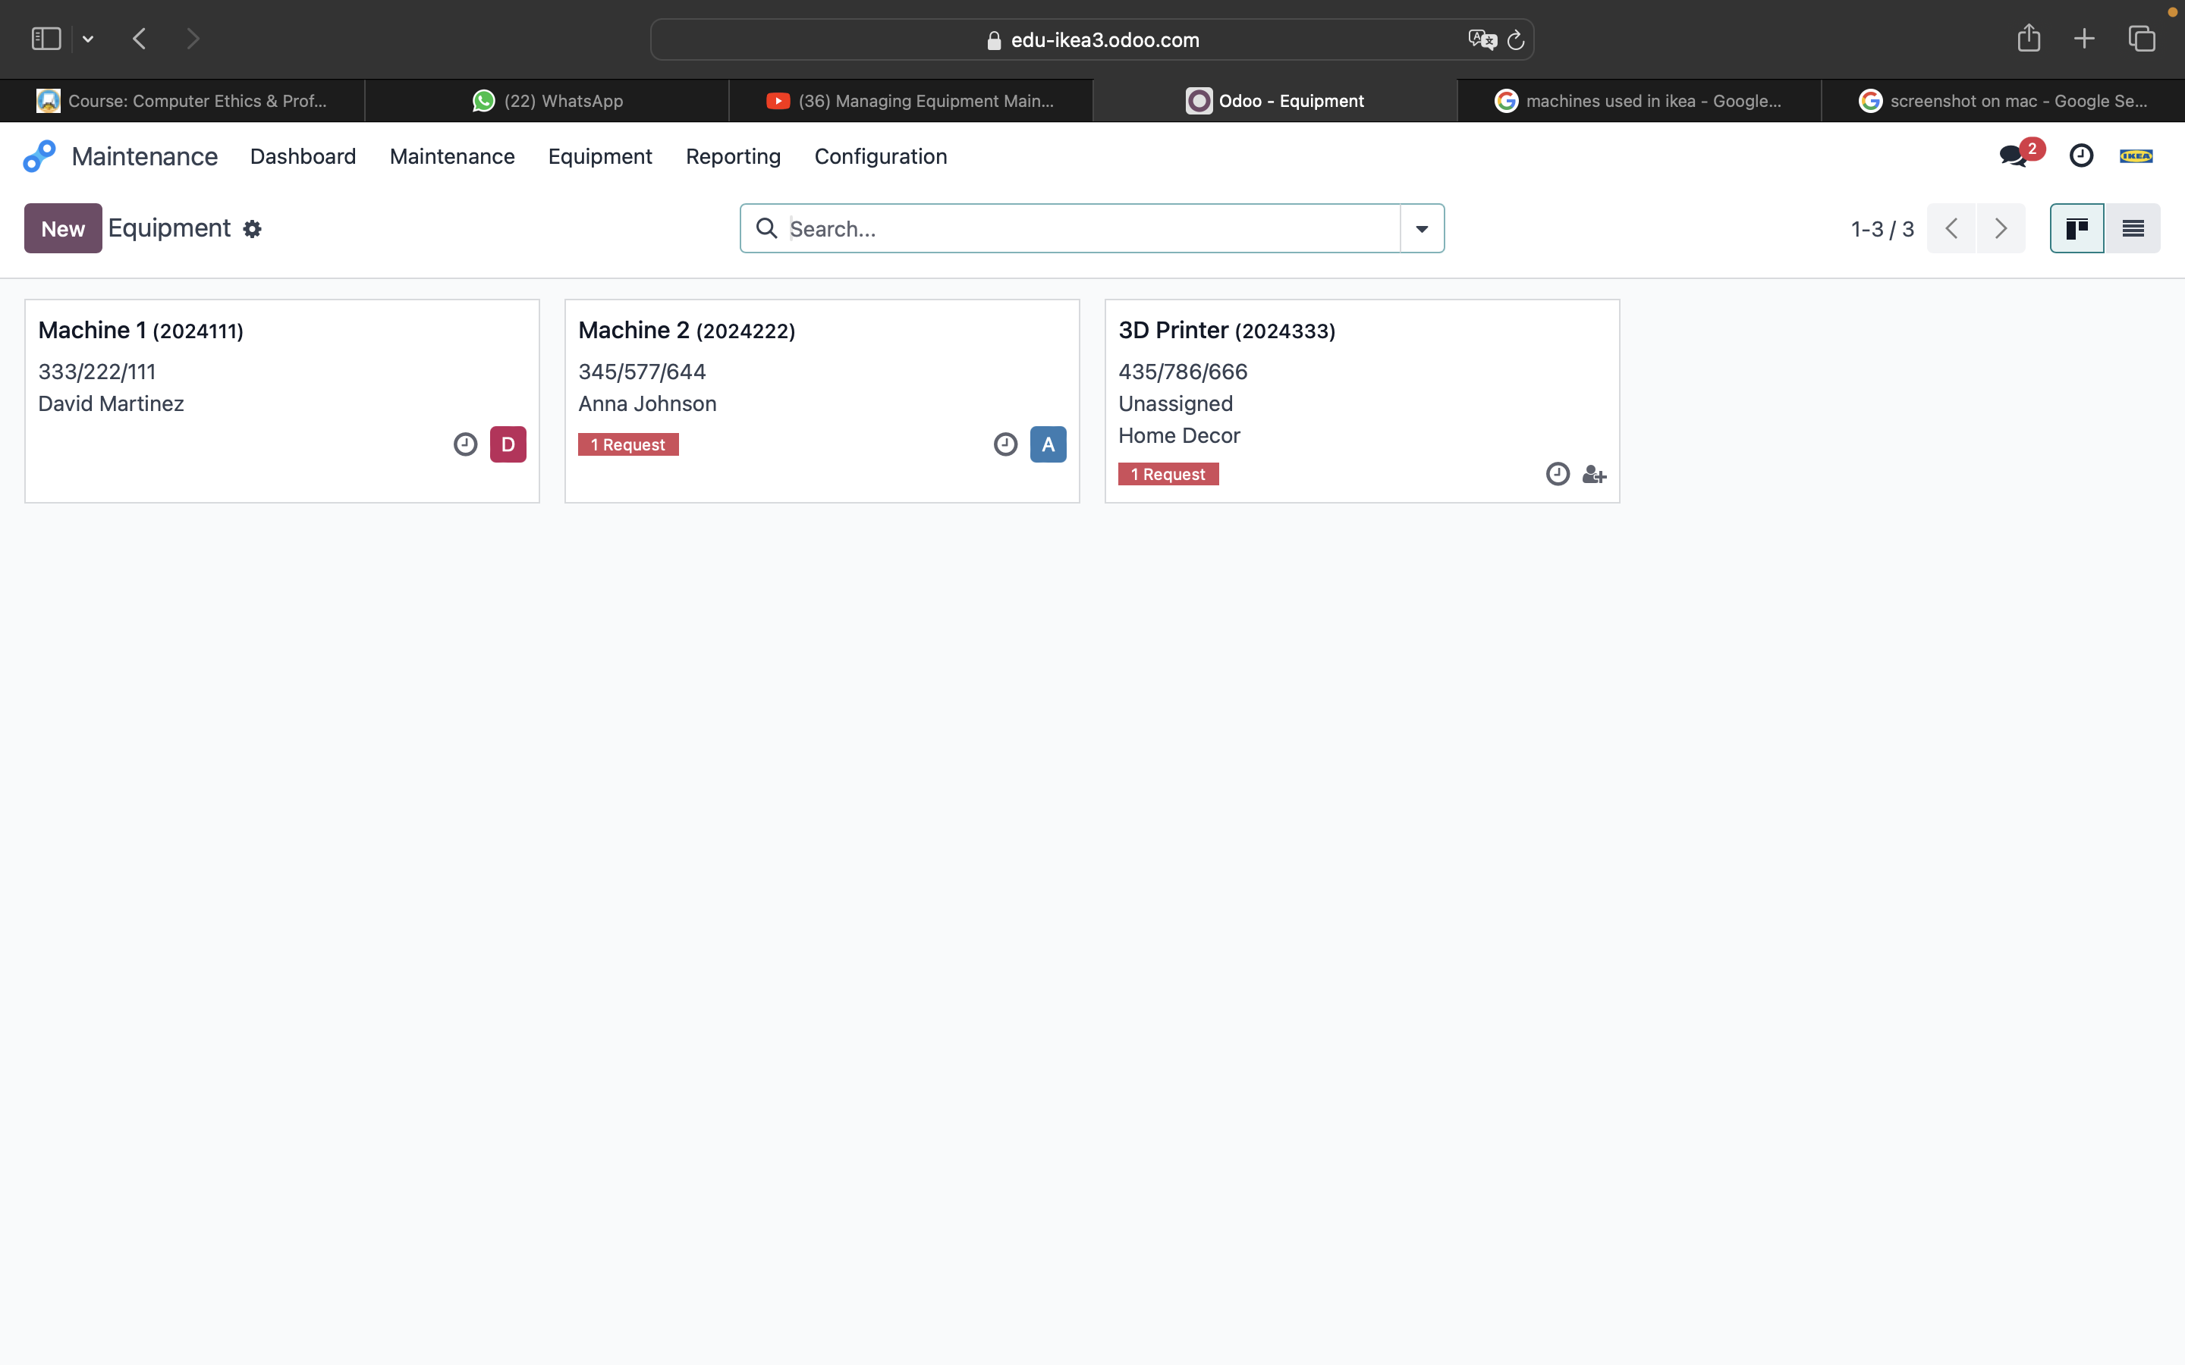

**Figure 2.2** examples of the equipment list

# Sales

The sales department of Ikea oversees selling the products. The department is made up of a sales team that deals with the sales orders, invoicing, sending the initial quotation and so much more, they also preserve client connections to promote repeat business and brand loyalty. In the sales department using Odoo, we get to decide the lead time of the product as well as the delivery method, taxes etc.

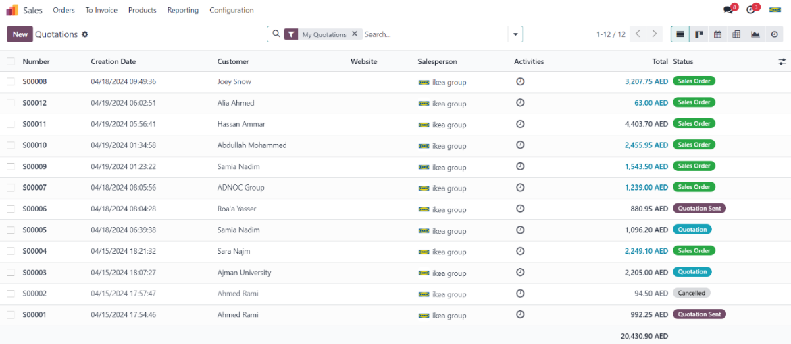

**Figure 3.1** shows the quotations and their status.

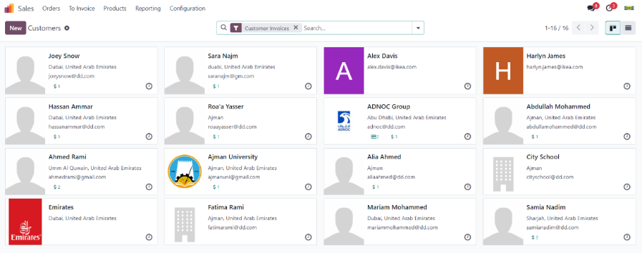

**Figure 3.2** access to our customers in sales and all their necessary information.

**Figure 3.3** shows the order date of the sales order “S00011” being the 19th of April 2024.

**Figure 3.4** shows that the scheduled date of the source document “S00011” being 23rd of April 2024 which is 4 days from the order date therefore having a lead time of 4 days.

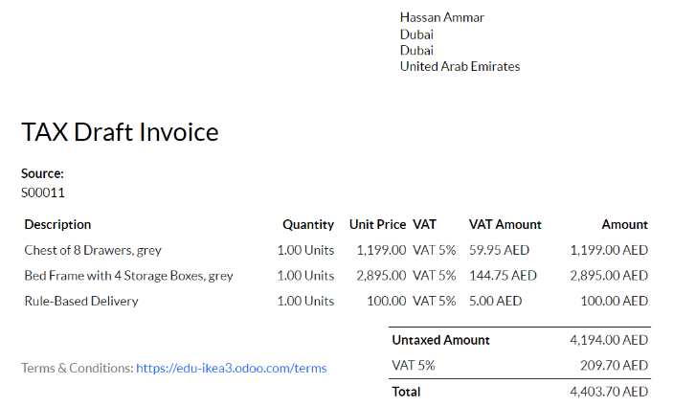

**Figure 3.5** in this invoice the Rule-Based Delivery method was chosen because the products wight more than 50kg.

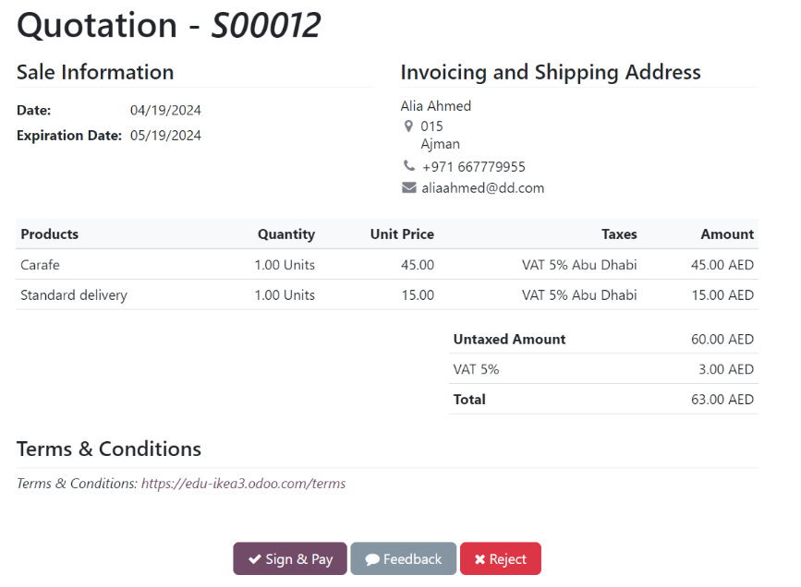

**Figure 3.6** in this quotation, the Standard Delivery was applied since the weight of the product that our customer Alia picked did not satisfy any of the Rule-Based Delivery method rules therefore making it a delivery of the Standard type. You will also notice the VAT being 5% and that is because Odoo automatically installs a tax localization package based on our company’s country when we first create an Odoo database.

# Products

IKEA sells several products in a different category such as outdoor seating, bedroom, and dining furniture. This module allows you to create and manage products. The product structure includes all the data required, like the name, cost, optional products, and the customer lead time. We also categorize products, which could help organize products into different categories such as outdoor seating, bedroom, and dining furniture.

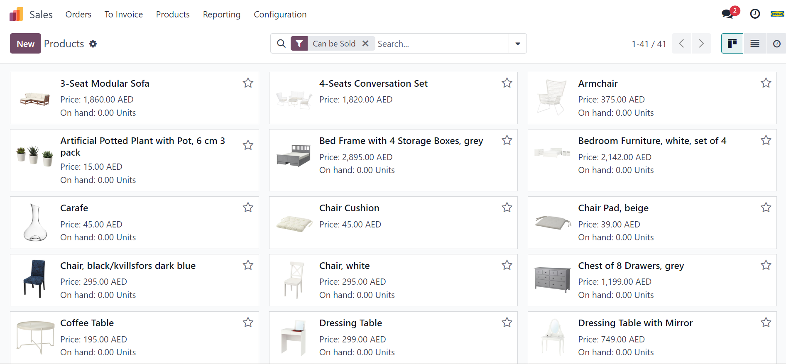

**Figure 4.1**

# Inventory

The Odoo Inventory application serves as both a comprehensive inventory management tool and an advanced warehouse management system. It facilitates efficient management of lead times, automates replenishment processes, and allows for the configuration of sophisticated routes, among other features. For IKEA, given the extensive scale of its product inventory and the nature of its merchandise, particularly furniture and upholstery, effective management of scrap is paramount. With a focus on the scrap module within inventory management, IKEA emphasizes the importance of mitigating potential losses due to damaged goods, which is a significant risk given the volume and nature of its stock. By prioritizing the scrap module, IKEA aims to ensure meticulous monitoring and handling of products that require disposal, thereby safeguarding operational efficiency and minimizing financial impact.

Scrapping of orders that are not required in the physical inventory or are just not present and need to be moved to virtual inventory where all scrap would be stored.

**Figure 5.1** all scrap orders.

# Purchase

The Odoo Purchase module simplifies buying processes for businesses. It helps manage orders, suppliers, and quotes easily. With it, you can create and track purchase agreements and reorder from vendors automatically. With Odoo's Purchase module, below shows how we did it. Suppliers have a lead time that they set out to when they can deliver these raw materials to us. That helps us understand the delivery date and when we can deliver it to our customers. Which ultimately helps in customer satisfaction. We set the min, max. quantity for each product for reordering, that then is sent as an RFQ automatically to the vendor when stock goes below min. Quantity.

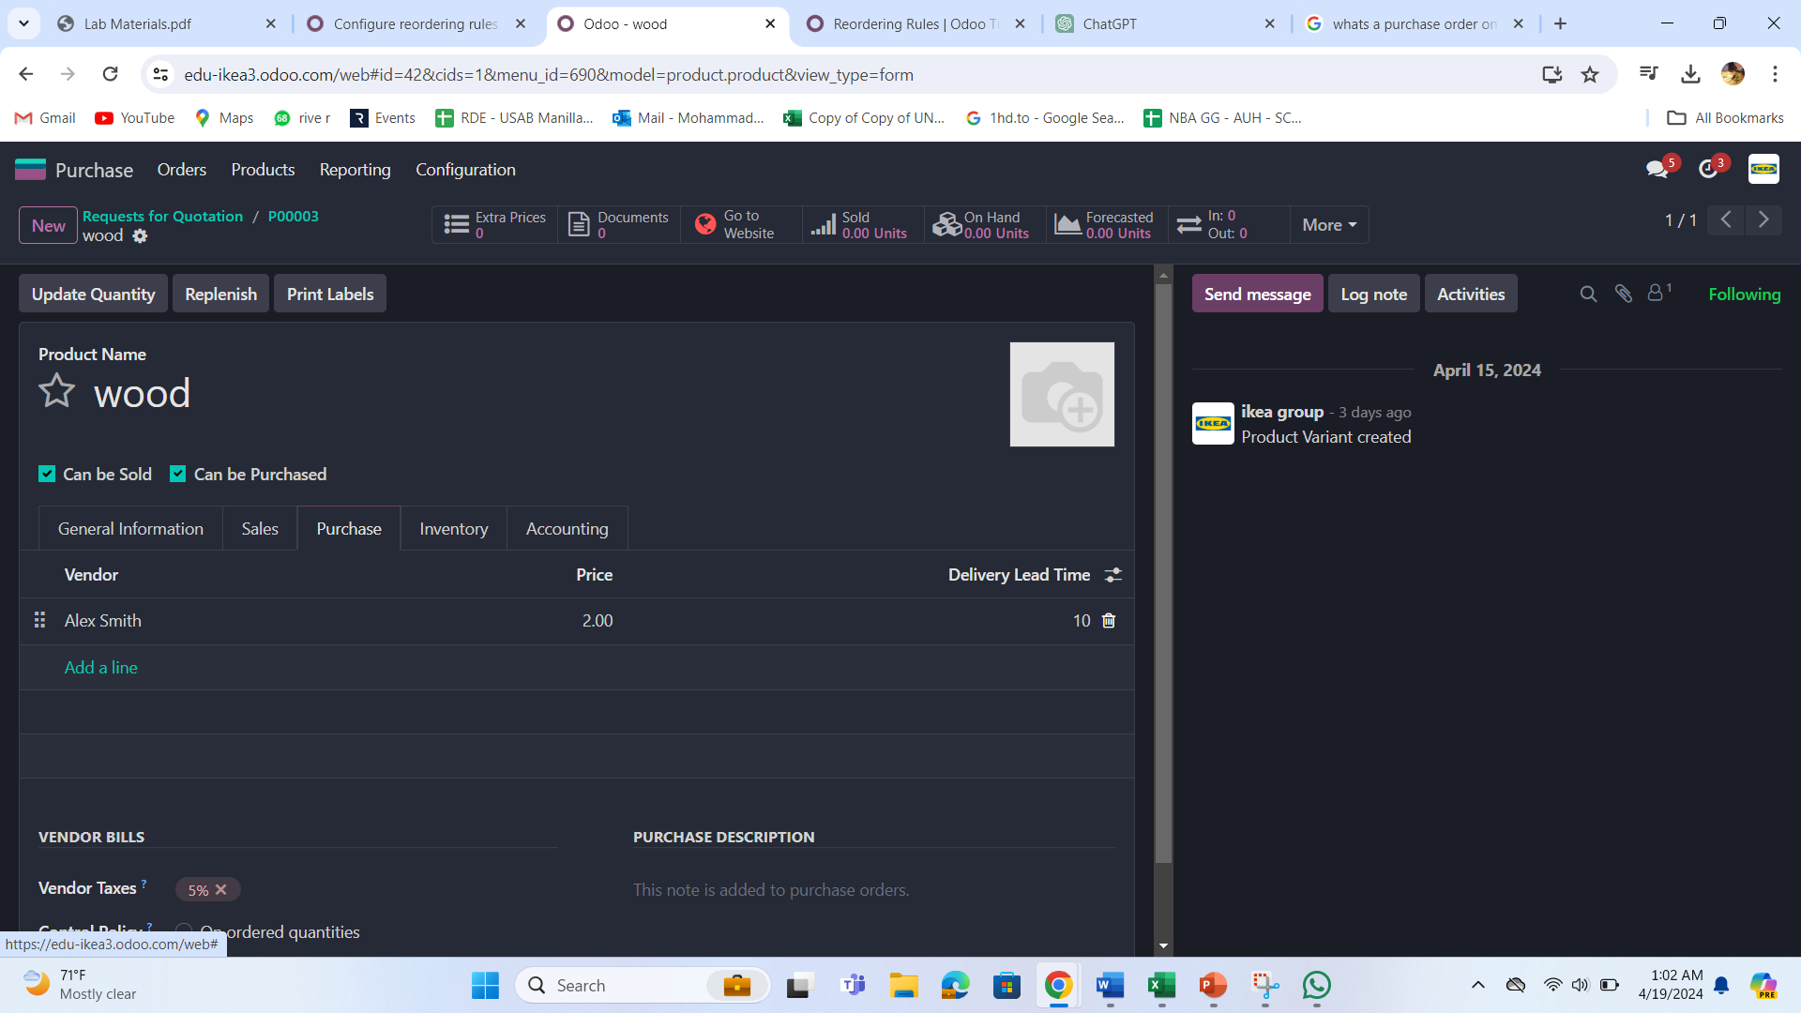

**Figure 6.1**

**Figure 6.2**

# Accounting

Accounting at IKEA relies on meticulous journal entries and a well-structured chart of accounts to track transactions effectively. With Odoo's accounting module, IKEA streamlines workflows and ensures accuracy. The chart of accounts provides us with all the available account. We specifically work on vendor bills.

We also worked on some journal entries by providing which account they belong to and for whom it is, like below for example we worked on invoices of the customers, recording them in their specific account, their due date, and their mode of payment i.e. either cash or bank account.

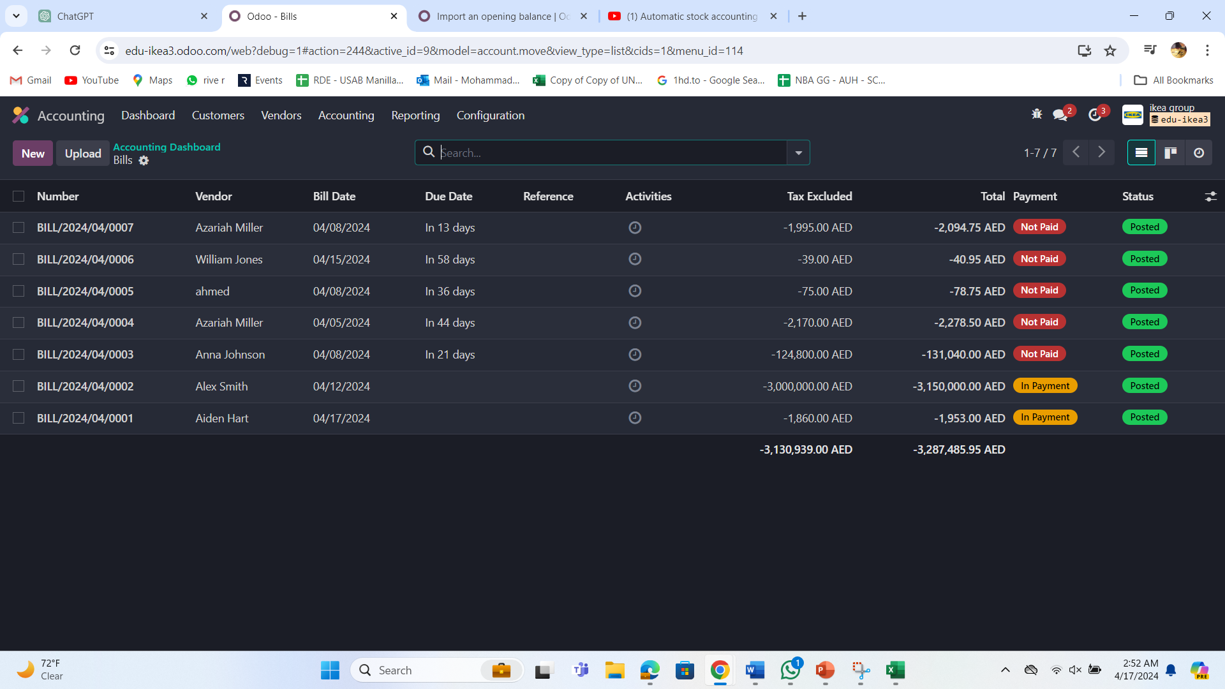

**Figure 7.1** these are the bills that Ikea must provide to its vendors. That amount credits into account payable. For an overview of all the vendor bills and their information we can use the “AGED PAYABLE REPORT”.

# Survey

Every company, big or small, should make sure to get feedback from the customers and employees for the long-term success of the company. IKEA makes sure to understand the importance of gathering feedback from our customers to ensure we're delivering the best possible products and services. That's why we've designed two different surveys to gauge customer and employee satisfaction and preferences.

Our "Feedback Form” aims to assess how satisfied customers are with our shopping experiences, including purchasing products and acquiring services.

The "Employee Appraisal Form" focuses on gathering insights from employee preferences and ideas, helping us understand what IKEA can do to give a satisfactory working environment.

These surveys are crucial for us to ensure we're meeting customer needs and expectations as we strive to build a successful business.

**Figure 8.1** preview of the survey and the display of the ending message.

**Figure 8.2** example of the questions added to the “Feedback Form” survey.

# Marketing

In any company, product and service marketing is an important function. Marketing of products can be done in multiple ways depending on business to business. In terms of IKEA, we have come up with two types of marketing strategies to reach a wide range of customers.

* Social Media Marketing
* E-mail Marketing

## Social Media Marketing

In this modern era, social media plays an important role in people's lives. Therefore, most companies choose social media platforms to market their company product, as it enables the company to reach many customers. The company's social media account is followed by millions of people which helps the company as well as the customers to connect with each other very easily. In our case, we used Facebook to promote our products. However, the Odoo social marketing app makes it easy for us to manage our data integrity, by linking the Facebook account with the Odoo account, so all the posts we do on Facebook will automatically show on the Odoo account, which makes employees aware of all the activity take place in the company.

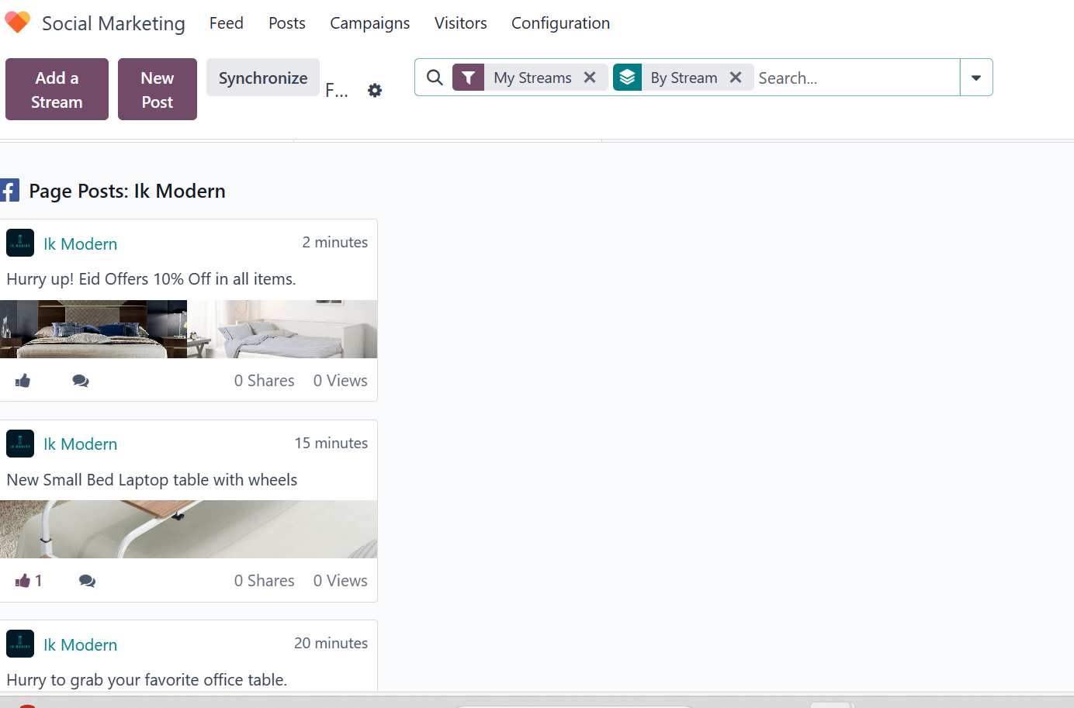

**Figure 9.1** shows the post we did on the Facebook page that automatically got linked to the Odoo account. We can manage our Facebook posts, Offers, and new collections through the Odoo social marketing app.

## E-mail Marketing

We have multiple customers in our company who prefer traditional marketing methods over social media marketing. Therefore, e-mail marketing is a perfect fit for our old-school customers, by ensuring that everyone has their e-mails, through which we can send them welcome messages, exclusive offers, and campaigns as well as inform them about our new collection to grab their attention.

**Figure 9.2** Shows how our customers receive a welcome message once they join our company website. On the other hand.

**Figure 9.3** we are sending a mail to our exclusive customers to inform them about our new collection in the market by scheduling this mail to be sent on 22/04/2024.

# Discuss

It is Odoo’s internal Chatting function which helps us with both private and group discussions and it relates to other applications of Odoo. It helps us to improve employees' internal communication, help them to discuss the work and do meetings in group calls as well and reduce internal e-mails. In discuss module there are two types of functions channels and direct messages, we can create channels for group chat, meetings, and calls. Channels can be public where anyone can join as well and they can be private for group messages. Direct message is used for sending private messages to an individual.

**Figure 10.1** shows the communication between the employees, as we can do both direct as well as group chat. On the other side, it shows the list of members present in the channels.

# Employees

The employees module is a complete tool designed to streamline human resources management within organizations. The functionalities include efficiently managing employee data, work location, contact information, job position, job title, and other related details. The module makes it easy for companies to maintain employee data and ensures that all employee data is accurate.

Companies may manage the entire recruitment process from creating job positions to hiring new employees by integrating this module with other modules like the planning module and adding the Payroll, Time Off, and Recruitment modules.

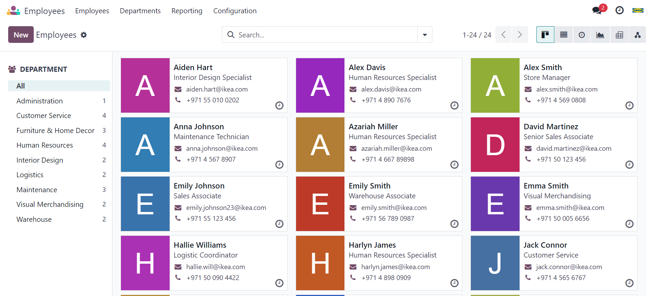

**Figure 11.1**

# Website

The website module in an ERP system for IKEA is critical for coordinating and smoothing out their web-based retail tasks with their actual store processes. This module considers constant synchronization of stock levels, guaranteeing that item accessibility and data are predictable across both advanced and physical platforms. It contributes to the efficient processing of online orders, from placing orders through to satisfaction and delivery, improving client experience by giving accurate, up-to-date information and smooth transaction capabilities. Furthermore, the website module gathers significant customer information that can be utilized for targeted marketing and to further develop what services offer, making it a fundamental aspect for keeping up with the functional proficiency and consumer loyalty that IKEA is known for.

**Figure 12.1**

# Calendar

IKEA uses the calendar module in their ERP system to organize and deal with many activities vital for keeping up with functional proficiency across its worldwide retail and manufacturing footprint. The functionalities given by this module incorporate a concentrated stage for booking and following all errands and occasions, for example, staff shifts, store tasks, conveyance timetables, and venture cutoff times.

The calendar module improves coordination across offices, guarantees that all arranged processes are lined up with corporate goals, and assists IKEA with keeping up with its standing for consistent store tasks and client care.

**Figure 13.1**

# Conclusion

In conclusion, the implementation of an ERP system like Odoo in IKEA's operations highlights a critical headway in how the organization deals with its complicated organizational activities. By integrating basic departments, for example, supply chain management, inventory, CRM, and human resources into a unified framework. IKEA upgrades its functional proficiency and responsiveness to client needs. Moreover, all Odoo’s modules further design the ERP framework to meet IKEA's particular prerequisites, guaranteeing consistent integration across both physical and technical platforms. This technological integration supports IKEA's development and market leadership as well as adds to a more feasible and customer-focused business model.

# References

1. IKEA. (n.d.). Our heritage. Retrieved April 19, 2024, from <https://www.ikea.com/us/en/this-is-ikea/about-us/our-heritage-pubde78e100#:~:text=IKEA%20is%20named%20after%20the,%22>
2. Appinventiv. (n.d.). IKEA shopping app. Retrieved April 19, 2024, from <https://appinventiv.com/portfolio/ikea-shopping-app/>
3. SAP. (n.d.). What is ERP? Retrieved April 19, 2024, from <https://www.sap.com/mena/products/erp/what-is-erp.html>
4. Forbes Advisor. (n.d.). ERP implementation. Retrieved April 19, 2024, from <https://www.forbes.com/advisor/business/erp-implementation/#:~:text=ERP%20implementation%20refers%20to%20the,)%2C%20into%20a%20single%20system>